**Code Promotion**

Date: 31 July 2025

Version 1.0

To commit code changes that will allow them to be utilized (upgrade) on higher environment, we need to Commit and Publish the changes that are ready to move up (those that have passed Peer Review). Nearly all of the Push will be accomplished in ServiceNow Studio.

The Code Push consists of 7 sections:

1. Initial Announcement
2. Commit (selected) Changes
3. Stash Changes
4. Publish Changes
5. Upgrade the higher environment
6. Apply Stashed Changes
7. Update the JIRA Board

Announcements will occur during the code promotion process:

1. CODE FREEZE
2. Committing Changes for Sprint XX, Push X, date
3. Commit complete
4. Stashing Changes
5. Changes Stashed
6. Publishing version 0.XX.0
7. Upgrading Test (or other environment) to version 0.XX.0
8. Upgrade completed.
9. Applying Stashes
10. Stashes Applied. Code Freeze completed. Check your update set!

**Process:**

1. CODE FREEZE:
   1. Make the Code Freeze Announcement and make sure you give developers enough time to respond if they are not in the Code Push meeting. Open Studio and select your application (HSI Academy Instructor Scheduling Portal)

1. **Committing Changes:** 
   1. From the header menu, under **Source Code**, click on **Commit Changes**. In the popup window, you will need to deselect everything (in the right pane, click on the top left checkbox by File).

* 1. Next select the update sets that need to be promoted in the left pane, next, in the right pane, click on the **File** checkbox – all of that particular update set’s changes will be selected.

**NOTE: You must DESELECT all update sets, then SELECT for the specific stories/update sets before proceeding with Committing Changes – otherwise ALL update sets will be committed.**

* 1. Click continue and give the Commit a name, the click Commit File(s)

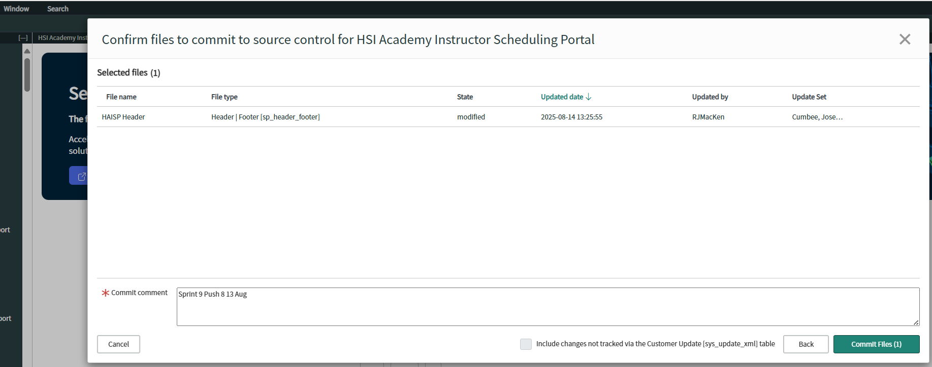

* 1. Make an announcement for the Committing Changes and when it is complete

1. **Stash Changes:** 
   1. In **Studio**, under **Source Code**, select **Stash Changes**. Provide a name (usually Stash for Push X noted above).

* 1. Click **Stash Changes**. This process takes quite a bit of time and will usually sit at 20% for quite a while (consider making a fresh pot of tea or even make lunch)
  2. Once the Stash is Complete, **CLOSE** the dialog window – do NOT click the green Apply Stashes button! If you do click the Apply Stashes button, you will have to start the Stash Changes sequence from the start.

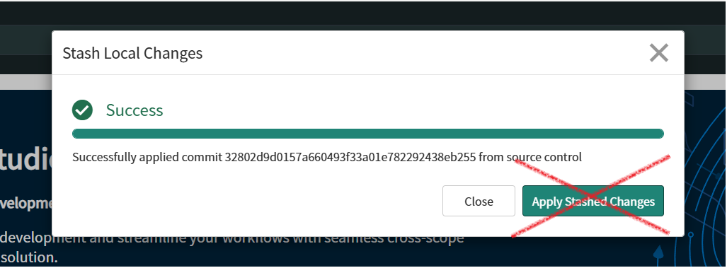

* 1. Make an announcement for the Stashing Changes and Stash Complete

1. **Publish Changes**
   1. Under **File**, select **Publish**.

* 1. In the popup menu, update the Version number and click **Submit**.
  2. If it asks about a Subscription, ignore that.
  3. Make an announcement for the Publish Changes and include the version number.

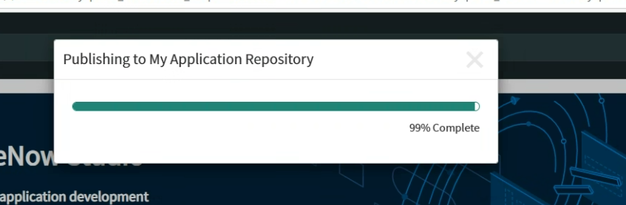

1. **Upgrade the higher environment**
   1. In the Test (or later, UAT, or the Production Environment), in the All Menu, type in **My Company Applications** and select it.

* 1. You can filter by your application name, when the refresh is complete, click the **Version** button and select the version you just published.

* 1. Make an announcement for the Update on the environment and when it is completed.

1. **Apply Stashed Changes**
   1. Under **Source Control**, select **Manage Stashes** and click apply on the Stash you created for this Push.

* 1. Make an announcement declaring Applying Stashed Changes and when it is done that they have been applied. Code Freeze Completed! Check your Update Sets.

1. **Update the Board**
   1. On the board, in the current Sprint, update all of the stories that were moved to the higher environment.